**Key Things to Know About the Play Center for the Parent (s)**

A $5.00 fee is due every Monday for the use of the Play center. These funds are used to supply cleanser, Kleenex, paper plates, and anything your toddler or infant may need while in the daycare.

Thank you,

Play Center Staff

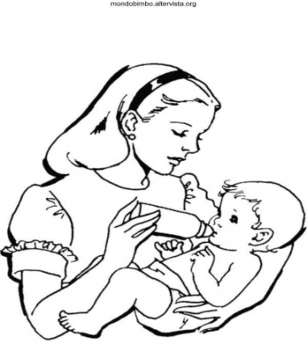 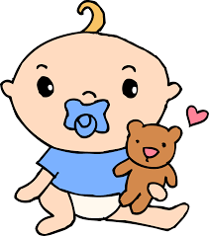

**PLAY CENTER**

Only parents with children are allowed in the play center. Any child/infant who has been absent from the play center for (4) days without notification will lose their place. Your child will be put at the bottom of the waiting list.

*** All items that you bring each week to the Play Center will need your child’s/infants full name and a cubby will be provided to keep the items. Play Center Staff is not responsible for loss or stolen items.

*** If you leave your infant/toddler unattended during lunch or after school you may lose your space in the play center and will be placed at the bottom of the list.

**WELCOME TO THE CAREER SUCCESS HIGH SCHOOL PLAY CENTER**



**Hours of operation- 8:30a.m. - 3:10 p.m. (Monday-Thursday)**

**9:00-12:00 p.m. (Friday)**

Before your infant/toddler can physically come to the play center we will need the original birth certificate and shot records. (We will make copies and return them the same day).

These are the items that you must bring weekly

* **10 diapers**
* **Baby wipes**
* **Change of clothing for your child**
* **1 can of formula/milk**
* **2 bottles minimum**
* **2 cups minimum**
* **Diaper rash ointment**
* **A clean blanket for naptime - 1 per child**

Label your entire child’s belonging with your child’s first and last name. If your infant/toddler misses 4 days without a doctor’s note or excused absence he/she will lose their spot and be placed at the bottom of the Play center wait list.

**\*\*Play center staff is not responsible for lost/stolen items\*\***

I _______________________________, have read and fully understand the rules and regulations of the Play Center. My signature verifies that all of the attached information has been read and/or explain to me.

Signature: ____________________________________________ Date: ___________________

**Medical Information**

Please check any existing medical information

|  |  |
| --- | --- |
| * HIV * Diabetes * TB * Other | * Asthma/Bronchitis * Sleep Apnea * Hepatitis * Heart Murmur |

Explain: __________________________________________________________________________________________________________________________________________________________________________________________________________________________________________

Allergies: _____________________________________________________________________ Explain: ______________________________________________________________________

Does Child/Infant have any physical, mental or emotional problem that we need to be aware of?

Yes________ No ________

If yes, please explain: _________________________________________________________________________________________________

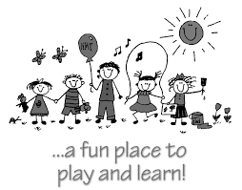

**Career Success High School Play Center**

**Enrollment Information**

**CHILD’S INFORMATION**

Child’s Full Name: ___________________________________Birth Date: _____/_____/_____

Address: ____________________________________________________________________

Home Phone: __________________________Cell Phone: _____________________________

City: _____________________________State: ___________Zip Code___________________

Nickname:_______________________________

**PARENT/GUARDIAN INFORMATION**

Mother’s Full Name:____________________________________________________________

Home Phone: ___________________________Cell Phone:______________________________

Address: ______________________________________________________________________

City: _____________________________State: __________Zip Code_____________________

Father’s Full Name:____________________________________________________________

Home Phone: ___________________________Cell Phone:______________________________

Address:______________________________________________________________________

City: _____________________________State: __________Zip Code_____________________

**PARENT/GUARDIAN WITH LEGAL CUSTODY: _________________________________**

Parents are: Married ____Living together _____Divorced_____ Separated ____Widowed____

Single_____

**Child Pick-Up Information**

Please list below the people who have **PERMISSION** to pick up your child. **NOTE: Anyone picking up your child must have proper picture ID.**

Name: _____________________________________________ Phone number: ____________________ Relationship to child: _________________________________

Name: _____________________________________________ Phone number: _____________________ Relationship to child: _________________________________

Name: _____________________________________________ Phone number: ____________________ Relationship to child: _________________________________

Please list those persons who **DO NOT HAVE PERMISSION** to pick up your child. Please explain the reason below or make sure to inform the play center instructor of the situation.

Name: _________________________________________Phone number: _________________________ Relationship to child: _____________________________ Reason: ______________________________ _____________________________________________________________________________________

Name: __________________________________________ Phone number: _______________________ Relationship to child: _____________________________ Reason: ______________________________ ____________________________________________________________________________________

Name: __________________________________________ Phone number: ________________________ Relationship to child: ______________________________ Reason: _____________________________ ____________________________________________________________________________________

**Emergency Contacts**

**Primary emergency contact (other than child’s parents)**

Name: ______________________________________________ Relationship to child: _______________ Phone number: _______________________________ Work phone number: ______________________ Address: _____________________________________________________________________________

*Please return this form along with a copy of your child’s birth certificate and current immunization records to the Play Center instructor. You will be notified when a spot is available for your child in the play center.*